**Linux**

**Task-1 to 10**

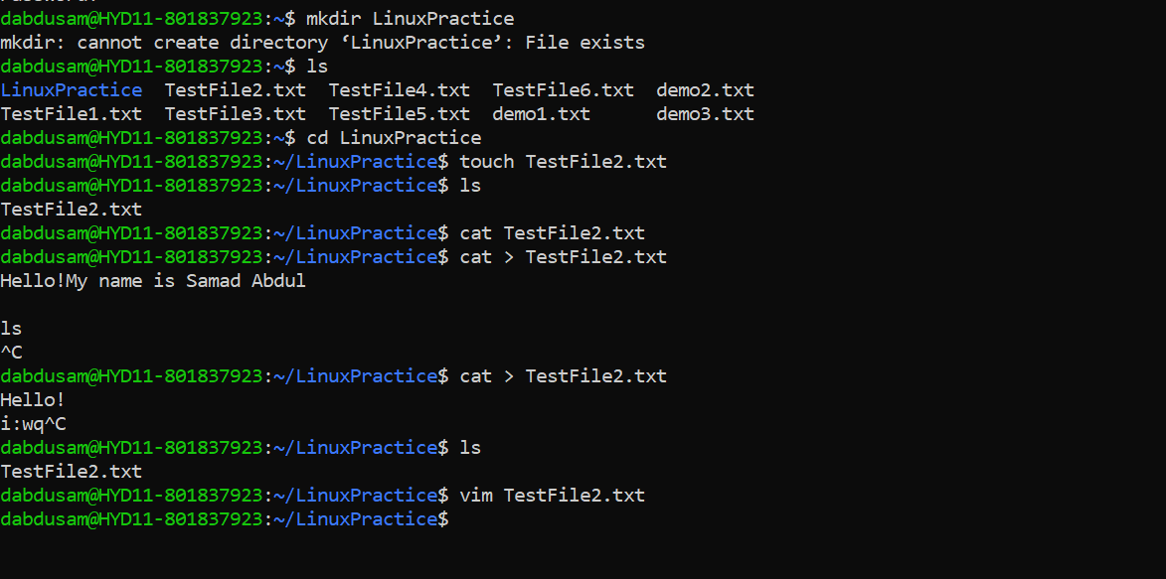

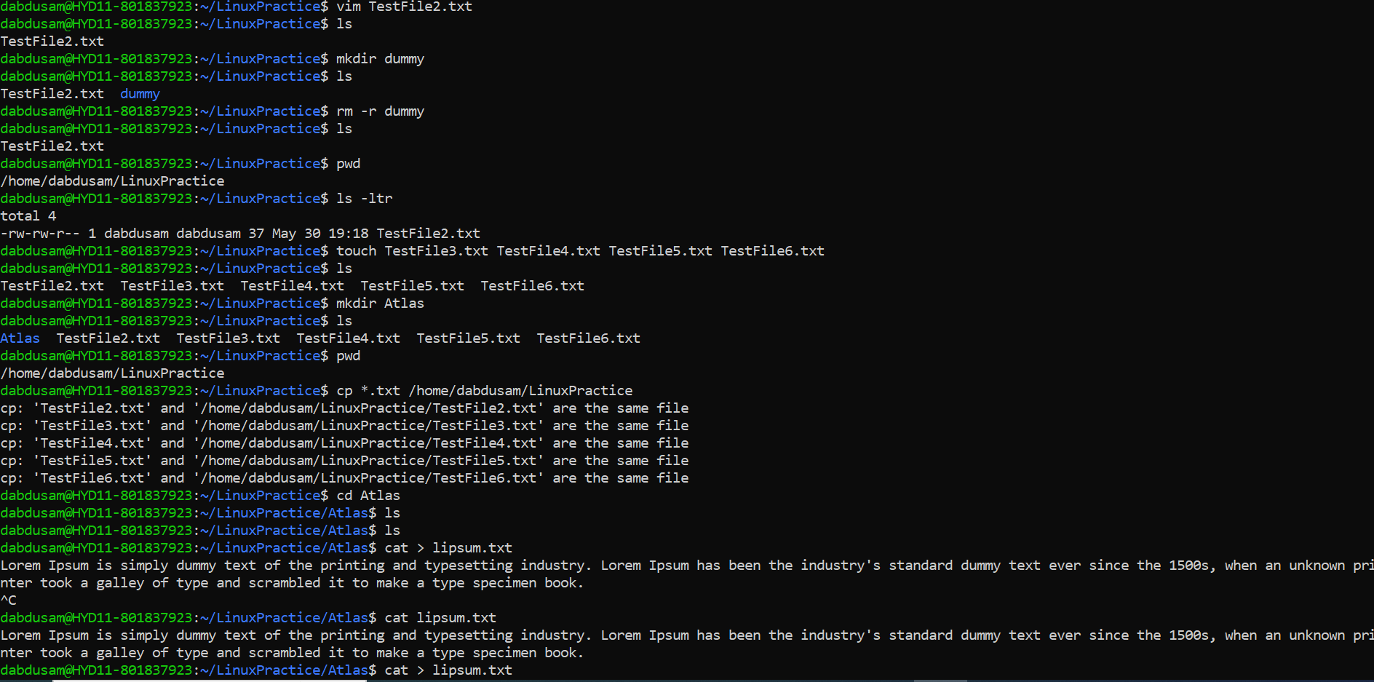

**Task -11 to 13**

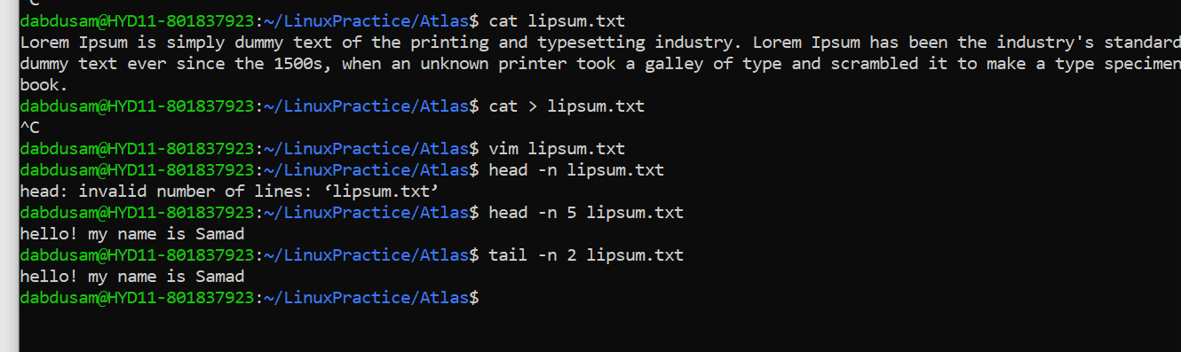

**Task- 14**

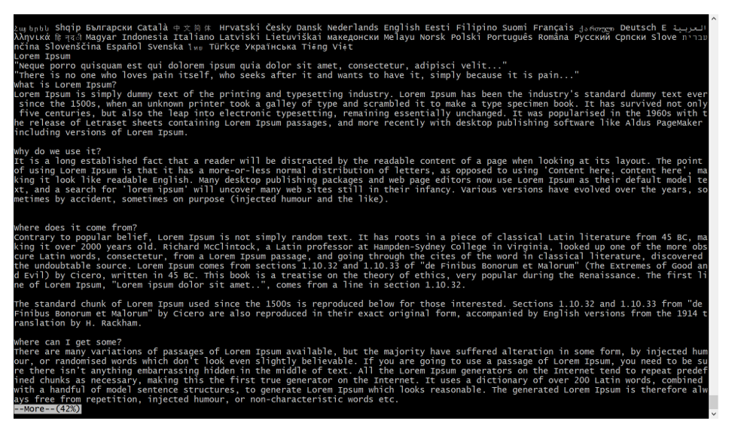

**Task-15**

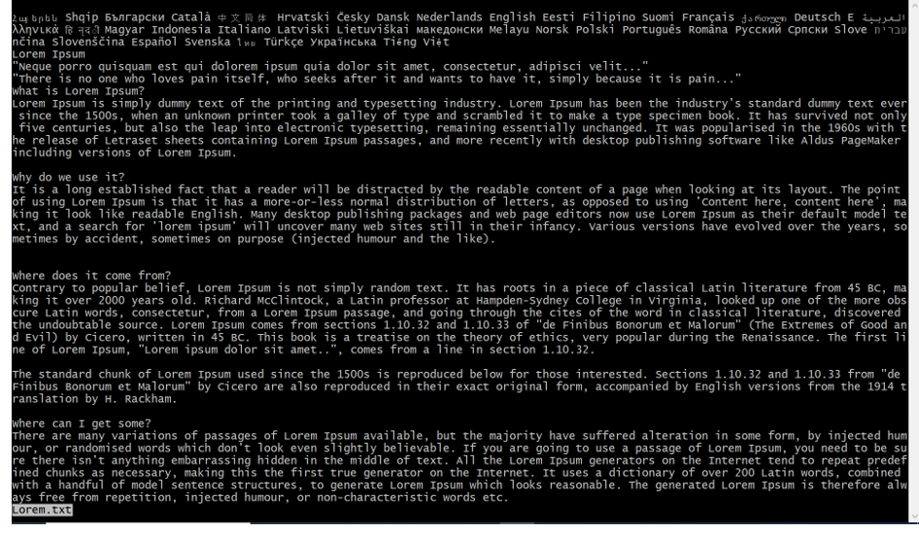

**Task- 16**

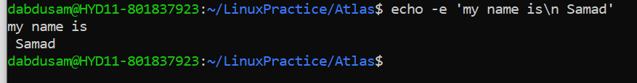

**Task-17 and 18**

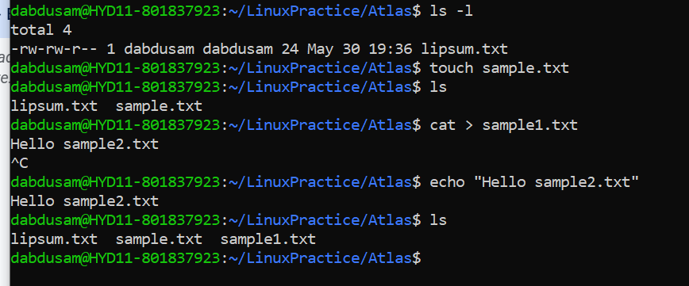

**Touch command**: this command will create a file without asking to enter text.

**Cat command**: with contact we can create files and also we can contact files

**Echo command**: this command enables the user to enter the text in double quotes and redirect it to the file.

**Task-19**

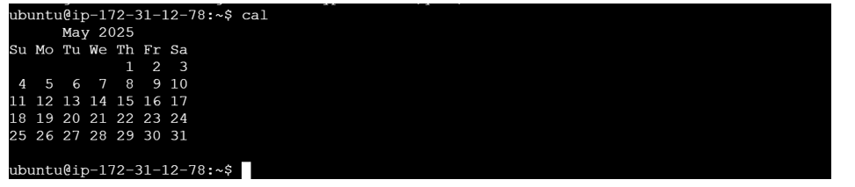

**Task-20 to 22**

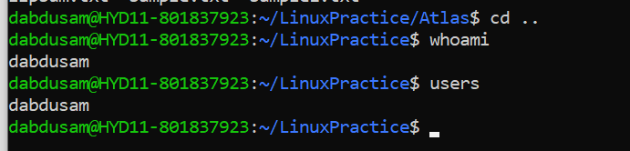

**Task- 23**

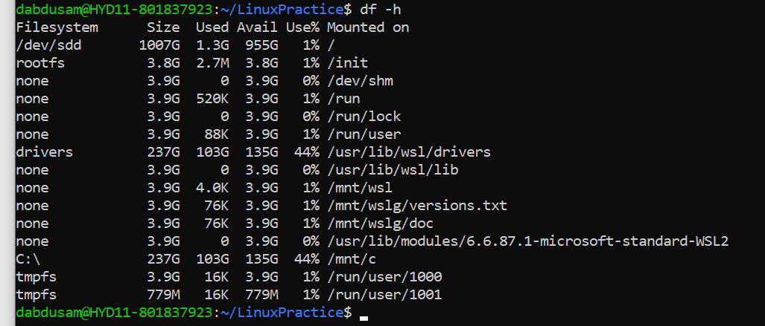

**Task- 24 to 26**

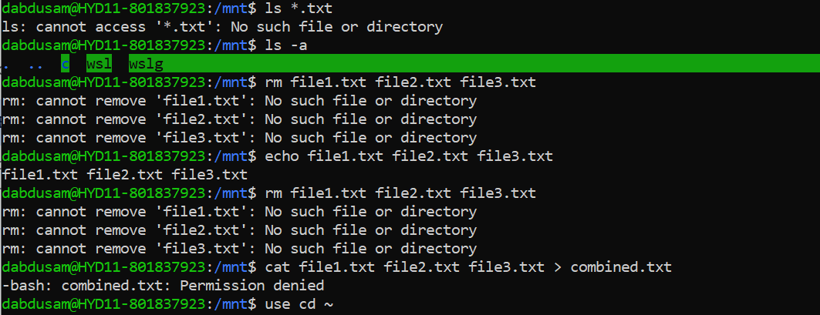

**Task- 27**

. Represent current directory

.. Represents parent directory

**Task- 28 and 29**

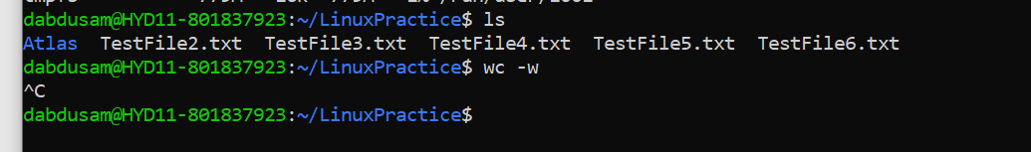

**Task- 30**

cat -b test1.txt : this command will give the output line by line with numbered format.

**Task -31 to 35**

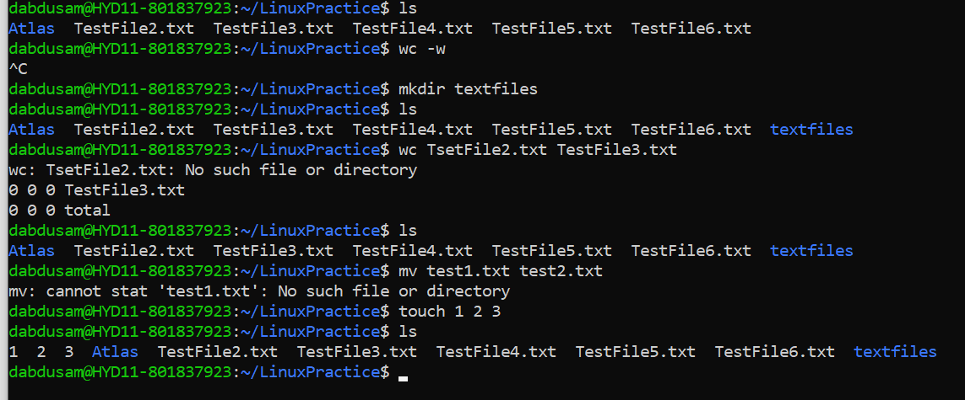

**Task-36**

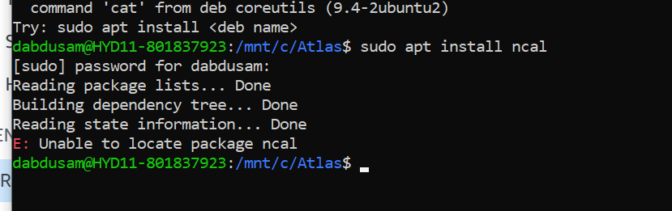

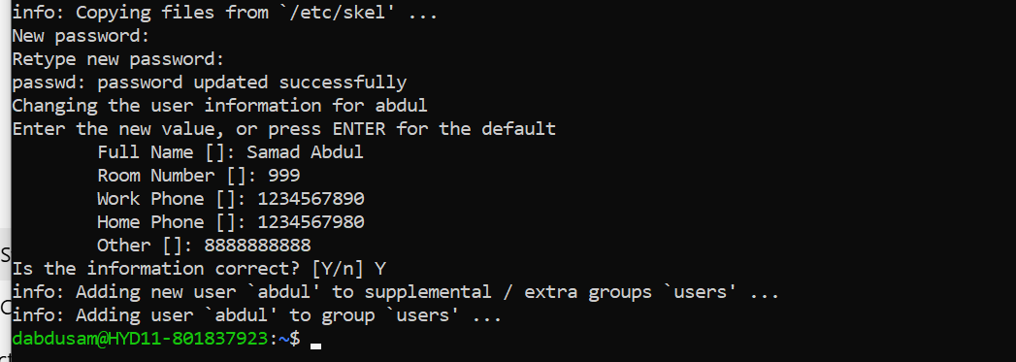

**Task-37**

